What happens after you make a complaint?

Your rights when using health or disability services

This Easy Read document is from the
What this document is about

Health and Disability Commissioner.

The Health and Disability Commissioner is also called HDC.

HDC looks after the rights of people who use:

- health services

- disability services.

To find more information about your rights there is an Easy Read document called: Your rights when using health or disability services.

You can find this Easy Read document on the HDC website: https://www.hdc.org.nz/disability/ easy-read-resources/

When you make a complaint to HDC it will be given to a Complaints Assessor.
Who looks after your complaint?

A Complaints Assessor is someone who looks after your complaint.

HDC will email or write and tell you:

- the name of your

Complaints Assessor

- how to contact your

Complaints Assessor.

You can contact your Complaints Assessor to:

- give your Complaints Assessor more information about your complaint

- talk about getting help from an Advocate from the Nationwide Health & Disability Advocacy Service

- ask questions about your complaint

- get an update.

Other people at HDC may also contact you about your complaint like:

- another Complaints Assessor

a Complaints Assessment Administrator.

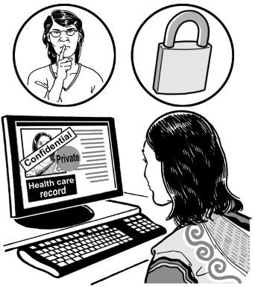
A Complaints Assessment Administrator makes sure information about your complaint is looked after and easy to find.

The final decision about your complaint will be made by:

- the Health and Disability Commissioner

or

- 1 of the Deputy Commissioners.

HDC looks at your complaint.
The complaints assessment process

HDC will use the complaints assessment process to:

- find out more about your complaint

- decide what to do next.

HDC makes sure your complaint is something the law says HDC is allowed to look into.

In the complaints assessment process the Complaints Assessor may:
- send a copy of your complaint to the provider you are complaining about
A provider is a person or organisation that offers health or disability services like:
- doctors
- dentists
- counsellors
- medical centres.

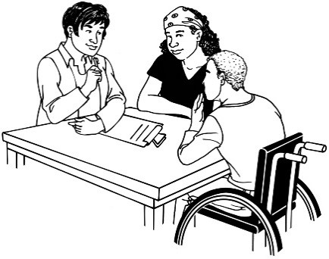
- ask for more information from the provider you are complaining about
- ask you for more information about your complaint
- ask other people for more information about your complaint
- ask someone who knows a lot about health or disability services some questions about the services you got.

It can take up to a year for the complaints assessment process to finish.

Your Complaints Assessor will:

- let you know what is happening with your complaint

- contact you every 10 weeks with an update.

HDC may:
Things that could happen with your complaint

- send your complaint to an Advocate from the Nationwide Health & Disability Advocacy Service so the Advocate can help you

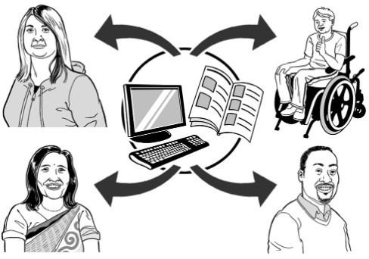
- send your complaint to the health or disability service provider it is about so the provider can:

  - try to fix the problem

  - say sorry to you.

HDC may also:

- investigate your complaint

see page 12 to read what
investigate means

- not do anything further if:

  - the health or disability service provider has looked at your complaint and has already sorted it

  - it happened a long time ago

  - someone else could deal with your complaint better

  - there is another reason. HDC will write and tell you the reason.

HDC may also:

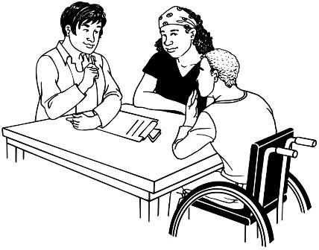
- tell the health or disability service provider to:

  - change the way they do things

  - say sorry to you

- tell you about places where you can get help.

HDC may send your complaint to:

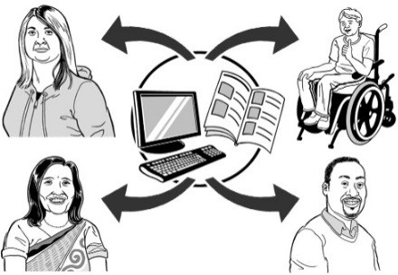
- the Ministry of Health

- a registration authority

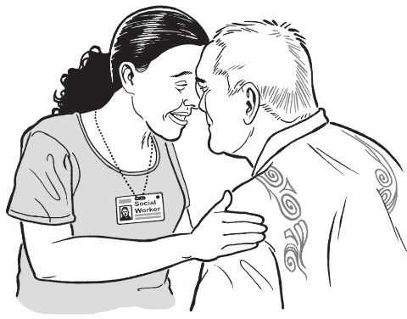
- the Privacy Commissioner

- a District Inspector

- or someone else.

HDC will write and tell you what will be done.

HDC may decide to investigate your complaint.
Investigations

This happens with only a small number of complaints.

If HDC decides to investigate your complaint that means HDC will look into whether or not there was a major issue with your rights.

If your complaint is to be investigated HDC will give your complaint to an Investigator.

An Investigator is a person who:
- takes over from your
Complaints Assessor
- asks more questions about your
complaint
- collects even more information
about your complaint
- talks to you about your complaint
- talks to the health or disability service provider you complained
about.

If an Investigator is looking at your complaint that means it is under investigation.

When your investigation is finished HDC will tell you what they found out about:

- your complaint

- your rights.

Many investigations take around
2 years to finish.

Investigations about many providers and issues will take longer.

HDC cannot help you get
Money
compensation or a refund.
Compensation is when you get money for something that has gone wrong.

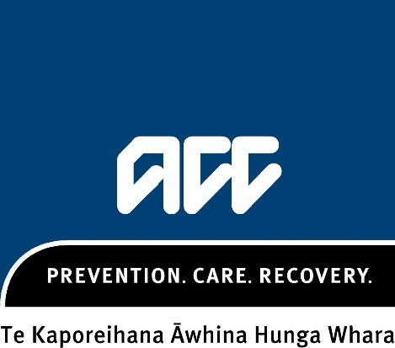
Sometimes people who get hurt can get money from ACC. You should talk to ACC if you think you got hurt by a health or disability service provider.
A refund is when you pay for something and then get your money back.

You can contact HDC:
How to contact HDC

- to get more information

- if you are worried.

You can call HDC on 0800 11 22 33. It is free to call this number.

You can email HDC at: hdc@hdc.org.nz

You can post a letter to:

The Health and Disability Commissioner
PO Box 1791

Auckland 1140

The HDC website is:

www.hdc.org.nz

This information has been written by the Health and Disability Commissioner.

It has been translated into Easy Read by the Make it Easy Kia Māmā Mai service of People First New Zealand Ngā Tāngata Tuatahi.

All images used in this Easy Read document are subject to copyright rules and cannot be used without permission.

Published: 2024

