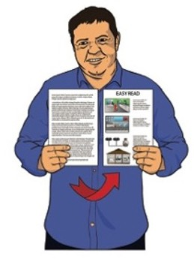

Pānui māmā

Ko ōu mōtika hei mahi ratonga hauora, ratonga hauātanga rānei

He tuhinga roa tēnei.
I mua i tō tīmatanga

He uaua pea te pānui tuhinga pēnei te roa.

Pānui māmā

Ko ētahi mahi e māmā ai te pānui:

- pānui ētahi whārangi noa iho

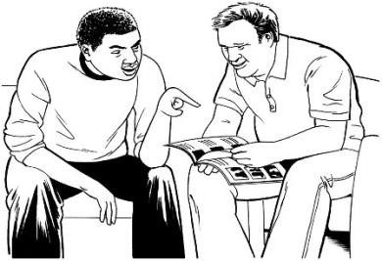
- whakaritea he wā wahangū hei tirotiro

- mā tētahi atu e pānui ki tō taha kia mārama koe

Whārangi nama
Ngā mea ka kitea e koe i konei

Mō te aha tēnei tuhinga? 5

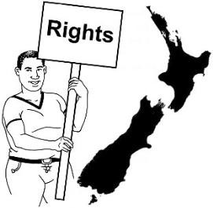
Tiakina ōu mōtika 6
Ōu
Mōtika

Ōu Mōtika 8

Mōtika 1: Mana 8

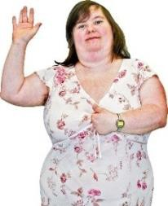
Mōtika 2: Manaakitanga 10

Mōtika 3: Tū rangatira motuhake 14

Mōtika 4: Tautikanga 15

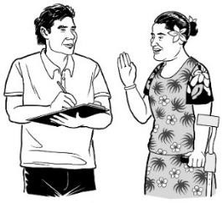
Whārangi nama:

Mōtika 5: Whakawhitiwhitinga whakaaro 17

Mōtika 6: Whakamōhio 19

Mōtika 7: Whakaritenga mōu ake 22

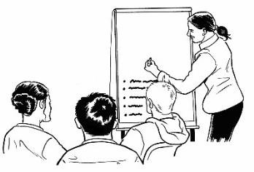
Mōtika 8: Tautoko 30

Mōtika 9: Ako me te rangahau 30

Mōtika 10: Amuamu 31

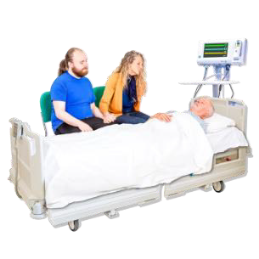
Mate whakaahuru 34

Whārangi nama:

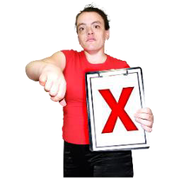
Ina whakaaro koe kāore ōu mōtika
e tutuki 37

Me pēhea e whakapā mai ai 41

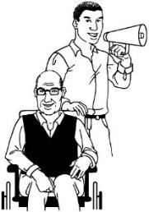
Me pēhea e whakapā atu ai ki tētahi
ratonga tautoko 44

Nā Te Toihau Hauora, Hauātanga

Pānui māmā
Mō te aha tēnei tuhinga?
tēnei tuhinga Pānui Māmā.

E kīia nei hoki ko Te Toihau Hauora, Hauātanga ko HDC.

Ka tiakina e HDC ngā mōtika o te tangata e whakamahi ana:

- i ngā ratonga hauora

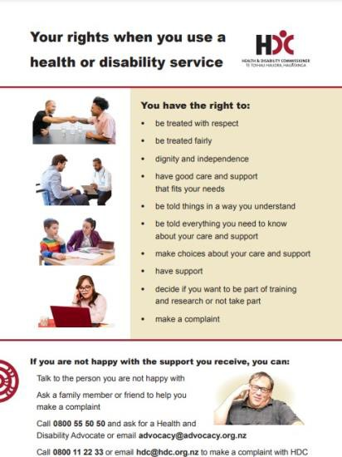
- i ngā ratonga hauātanga.
Ko ōu tika (mōtika) ina whakamahia e koe he ratonga hauora, hauātanga rānei
Kei a koe ngā tika (mōtika):
- kia tika te whakaute mai
- kia tika te manaaki mai
- kia tū rangatira, tū motuhake
- kia tika te atawhai me te tautoko e tutuki mai ai ōu hiahia
- kia mārama ki ngā kōrero
- kia tukua katoatia te kōrero mō tō atawhai me tō tautoko
- he mana kōwhiri mō tō atawhai me tō tautoko
- kia whai tautoko
- kia kōwhiri ina hiahia koe kia whāia he whakangungu, he rangahau, kāore rānei
- tuku he amuamu
Ki te kore koe e harikoa ki te āhua o te tautoko mai, ka taea e koe:
Te kōrero atu ki te tangata nāna koe i whakararu
Pātai atu ki tētahi o te whānau, ki tētahi hoa rānei hei āwhina i a koe kia tukua he amuamu
Waea atu ki 0800 55 50 50 kia tonoa he kaitautoko
Hauora, Hauātanga kia īmēra rānei ki a advocacy@advocacy.org.nz
Waea atu ki 0800 11 22 33 īmēra atu rānei ki a hdc@hdc.org.nz
hei tuku amuamu ki a Te Toihau Hauora, Hauātanga (HDC)

Ka tiakina e HDC ngā mōtika tangata i raro i te Tikanga Ratonga Hauora, Hauātanga mō ngā Mōtika Kiritaki.

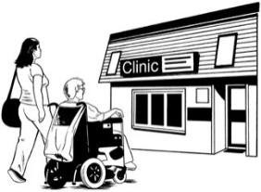
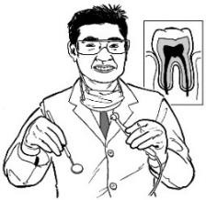
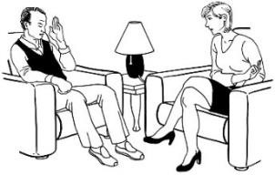

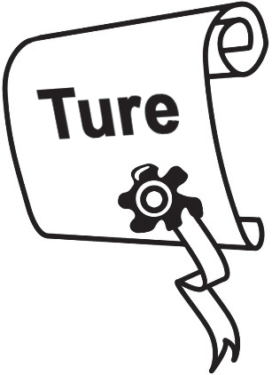
Kei ngā tāngata katoa te whakahaumaru i raro i te ture o Aotearoa e whakamahi ana te ratonga hauora, hauātanga rānei.
Tiakina ōu mōtika

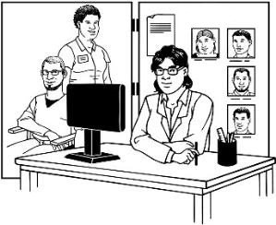
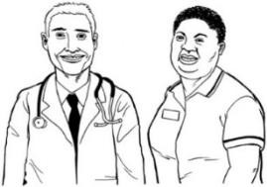
Me mahi e tēnā kaiwhakarato hauora, hauātanga me tēnā kia whakaaro nui ai tā rātou ratonga ki ōu mōtika.
He tangata, he rōpū rānei te kaiwhakarato hei whakarato hauora,
hauātanga pēnei i ngā:
- rata/tākuta
- kainiho
- kaitohutohu
- whare hauora.

Mana
Ōrite
Hei whakaaro nui ki a koe mā tētahi
atu:
- e tōkeke atu
- e atawhai atu
- e mōhio ana ki ōu mōtika
- e kore e huri tuarā ki ōu mōtika.

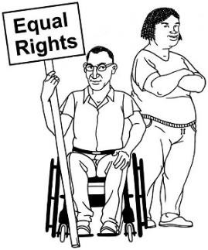
Me pēnei ngā kaiwhakarato:

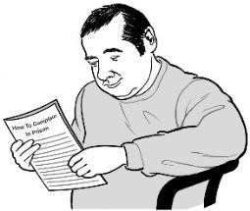
- whākina ōu mōtika ki a koe

- tukua koa kia whakamahia ōu mōtika.

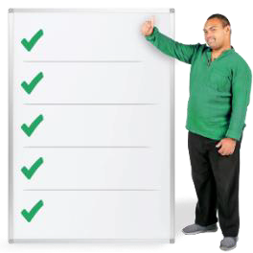
10 ōu mōtika i raro i tō Aotearoa ture ina mahia ana he ratonga hauora, hauātanga.
Mō oū mōtika

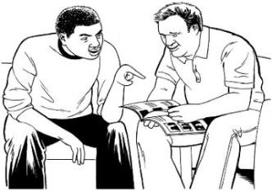
Kei tēnei wāhanga o te tuhinga nei he whakamārama mō ōu mōtika.

Mōtika 1: Mana

Me pēnei ngā kaiwhakarato:

- kia whakaaro nui ki a koe

- kia matatapu āu kōrero

Ko te matatapu kia kaua e tuari mōhiohio mōu ki tētahi atu ki te kore koe e whakaae.

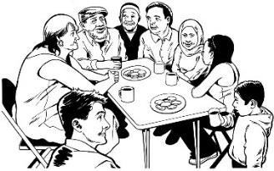
Me whakaaro ngā kaiwhakarato:

- ki ōu matea whakahoahoa

- ki ōu matea whakapono pēnei i te haere ki te whare karakia

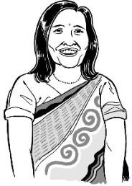
- ki ōu matea ahurea pēnei kia kōrerotia tō reo ake

- matea ā-iwi pēnei i ngā tikanga.

Mōtika 2: Manaakitanga

Me kaua e rerekē te manaakitanga i a koe i runga:

- i tō pakeketanga

- i tō ira

- i tō iwi

- i tō mahi kāore rānei

- i tō hononga tangata

- i te āhua o tō whānau.

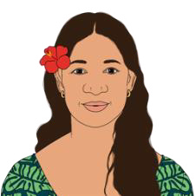
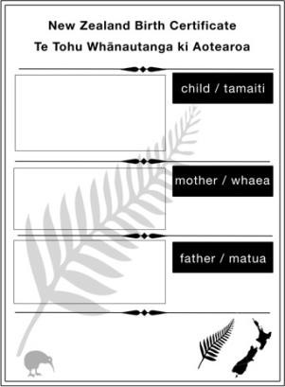
Ko te ira ko tō momo pēnei pea:
- i tō ira i whānau mai ai koe
- i tō ira e rerekē ai i tō te mea
o tō whānautanga mai
Tokomaha ngā ira tae atu ki te:
- wahine
- tāne
- takatāpui
- ira tāhūrua-kore
- irarere.

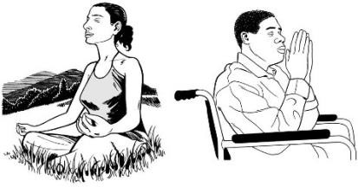
Me kaua e rerekē te manaakitanga i a koe i runga:

- i tō whakapono

- i ōu hauātanga

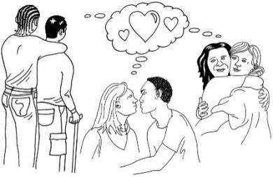
- i tō aronga taera.
Ko te tikanga pea o te aronga
taera:
- tāne moe tāne / wahine moe
wahine
- tāne moe wahine
- hōkakarua / hōkakarau
- hōkakakore.

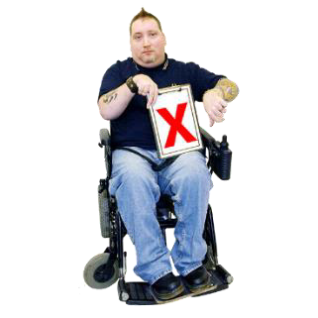
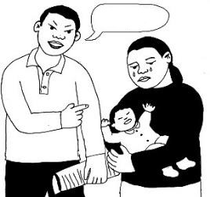
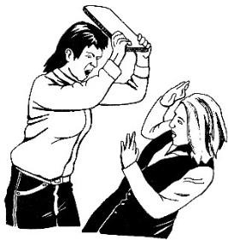
Me whakamahi e koe ngā ratonga me te korenga:
heahea

- e mahi i tētahi mahi e kore rawa ai e hiahia koe

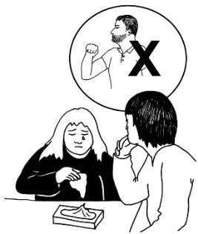
- e whakawehi i a koe pēnei i te whakamamae i a koe ki te kore koe e mahi i tētahi mahi

- hawene.
Ko te hawene he mahi whakamamae nā tētahi ki a koe ahakoa ka kī atu
koe ki a rātou kia whakamutua.
He nui ngā momo hawene pēnei:
- i te whakaiti mā tētahi ingoa
rerekē
- i te patu tangata
- i te tuku īmērā hākere

Mōtika 3: Tū rangatira motuhake

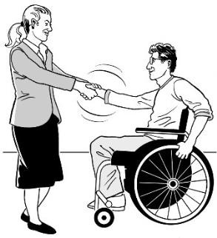
Me whakaaro nui ngā kaiwhakarato ki tō:

- mana

- tino rangatiratanga.

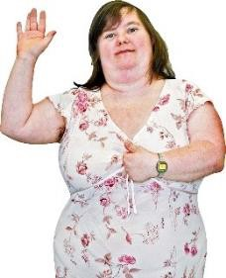
Ko te mana e whakaaro nui ana koe ki a koe anō.

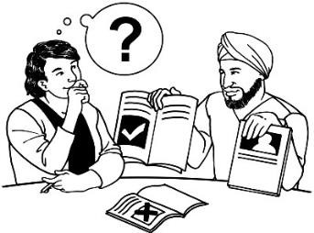
Ko te tino rangatiratanga, māu anō āu whiriwhiri.

Mōtika 4: Tautikanga

Ko te tikanga o ngā paearu tika me mahi ngā ratonga:

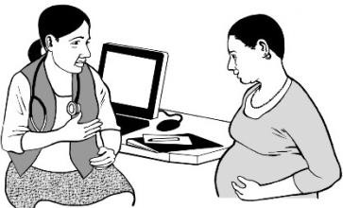
- kia kounga te manaakitanga

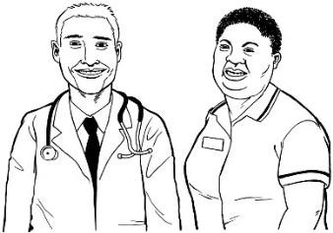
- kia mahia e tētahi mātanga e mōhio ana ki te mahi

- hei tautoko i a koe kia tino pai rawa atu tō oranga

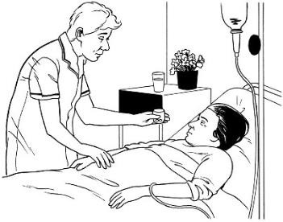
- kia pai te manaakitanga ahakoa te momo kia kore ai te mamae e kino rawa atu.

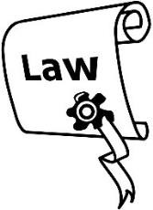
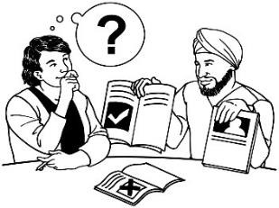
Me pēnei ngā ratonga:

- kia whāia te ture

- kia tika te mahi a ngā kaimahi

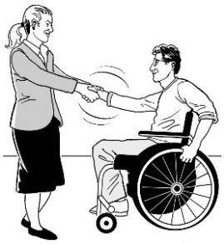
- kia tika te āhua o te manaakitanga

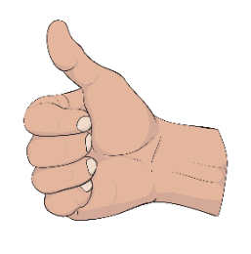
- me matatika.
Ko te matatika he mahi pēnei i te
- mahi pono
- whiriwhiri tōkeke
- kia manaaki i te tangata.

Mōtika 5: Whakawhitiwhitinga whakaaro

Me hoatu atu mōhiohio ki a koe kia mārama pū ki a koe.

Me ui atu kia whai kaiwhakamāori
mēnā:

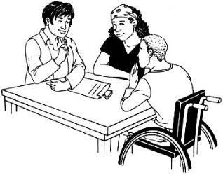
- ka hiahia koe ki tētahi

- e wātea ana tētahi.

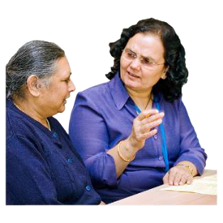
Ko te kaiwhakamāori he tangata māna te kōrero a tētahi e whakamārama ki te reo e mārama ana koe.

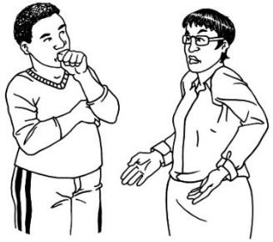
Ko te whakawhiti whakaaro:

whaka- haumaru

- ka tū i tētahi wāhi haumaru

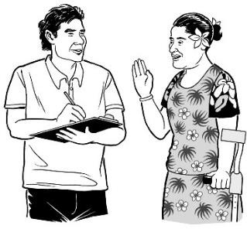
- ka mahia:

  - he māmā kia mārama

  - he hua mō te katoa

  - he pono.
Ko te kōrerorero pono:
- he tika, he pono
- he whakaputa whakaaro ki
tāu e pono ai
- kia kaua e huna mōhiohio i te tangata ina hiahia rātou ki
taua mōhiohio.

Mōtika 6: Whakamōhio

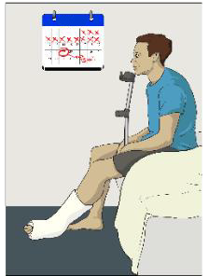
Me whakamōhio atu i a koe:

- ngā mate kei a koe

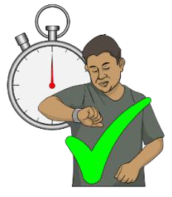
- te roanga atu o te wā kia whakamahia e koe tētahi ratonga

- he mōhiohio hei āwhina i a koe kia whiriwhiri whakaaro

- he kitenga nā ngā kaiwhakarato:

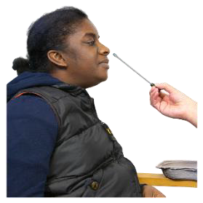
  - ngā whakamātautau

  - ngā maimoatanga.

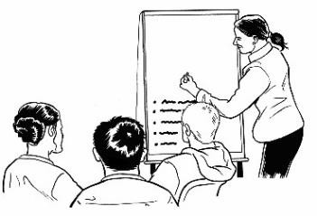
Me whakamōhio atu hoki i a koe ina uru koe ki tētahi:

- mahi whakaako

rangahau.

Ko te rangahau he mahi e rapu ana te tangata i ētahi mātauranga.

Me whāki katoa atu i ngā whiringa ka taea e koe pēnei:

- i ngā āhuatanga hē ka puta

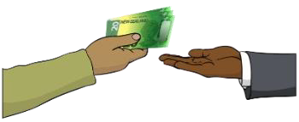
- i ngā āhuatanga papai ka puta

- i ngā utu me utu e koe

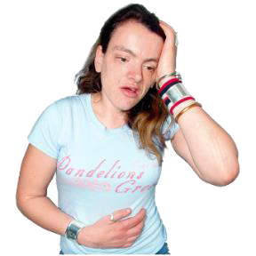
mate āpiti

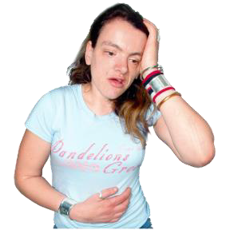
Ko te mate āpiti he mea pērā i te ānini, te rongo mate rānei nā te rongoā, te maimoatanga rānei.

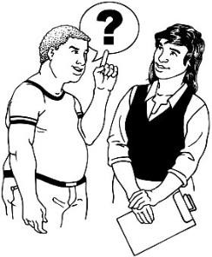
Me hoatu whakautu ki āu pātai mō ngā ratonga pēnei:

- i te ingoa o te kaiwhakarato

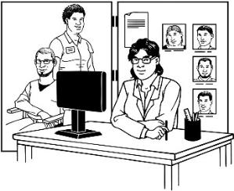
- i te whakangungu a te kaiwhakarato

- i te tohutohu a te kaiwhakarato

- i te pēhea e ui ai mō ngā whakaaro o tētahi atu kaiwhakarato

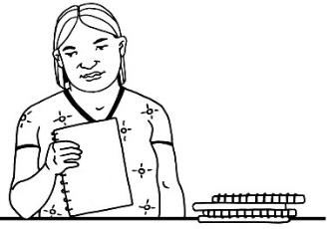
- i ngā hua o tētahi rangahau i uru atu ai koe.

Kei a koe te mana hei ui atu kia tuhia mai he mōhiohio māu.

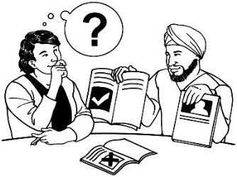
Mōtika 7: Whakaritenga mōu ake

Me hoatu ratonga ki a koe e mutu rā anō ai i a koe:

- tētahi whiringa mōhio

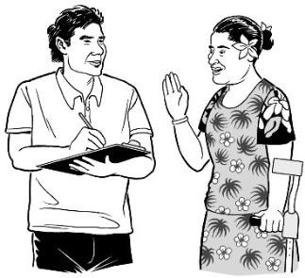
- tētahi kupu whakaae te hoatu.
Ko te tikanga o te whiringa mōhio
kia:
- whakamōhio atu i a koe i ētahi mōhiohio e hiahiatia ana mō te
ratonga
- tino mārama koe ki te tikanga
o te mōhiohio
- whiriwhiri koe ki te whakamahi
i te ratonga, kāore rānei

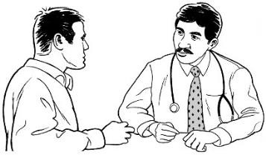
Me whakaaro ngā kaiwhakarato he matatau koe, māna he take tō rātou, kāore i te matatau.
Ko te kupu whakaae anō kia:
- nui te mōhiohio e taea ai e koe
te whiriwhiri whakaaro
- whakaae koe ki te whakamahi
ratonga
- mārama ki a koe:
o te tikanga o te whakamahi
ratonga
o ka aha ina whakamahi
ratonga koe.

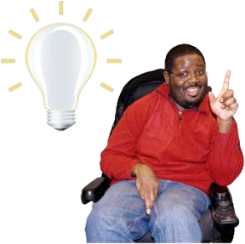

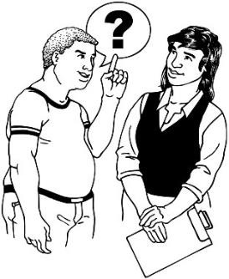
Kāore i te matatau ētahi tāngata hei whiriwhiri i runga i te mōhio.
Mā te matatau ka taea e koe:
- te mōhiohio te mārama
- te whiringa pai rawa atu te
whiriwhiri
- tuku pātai ki te kore koe e tino
mōhio ki tētahi āhuatanga.

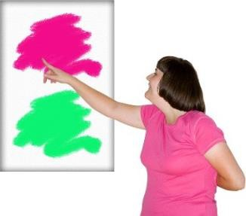
Ki te kore koe e matatau hei whiriwhiri i runga i te mōhio me āhei tonu koe:

- ki te whiriwhiri ki tāu e mārama ana

- ki te tuku kupu whakaae mō ngā āhuatanga e mārama ana koe.

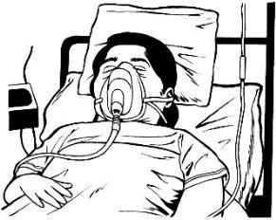
I ētahi wā kāore e taea e ētahi te tuku i tā rātou kupu whakaae pēnei e mauri moe ana rātou.
Mēnā e mauri moe ana koe,
kāore koe e:
- aroā ana ki ngā āhuatanga
i tō taha
- āhei ana ki te whakawhiti
kōrero/kōrero
Ina mauri moe ana koe ānō nei e au ana tō moe me te uaua hei
whakaoho

Me he ratonga e hiahia ana engari tē taea kupu whakaae te tuku, me pēnei ngā kaiwhakarato:

- me mahi hei oranga mōu

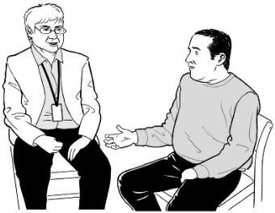
- me rapu ina tuku kupu whakaae koe ahakoa te aha

- me kōrero ki ētahi atu tāngata e mōhio ana ki a koe hei rapu ōu whakaaro.

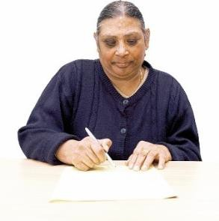
Me whakaae ā-tuhi e koe mēnā ka whakaae koe ki te:

- noho hei wāhanga o tētahi rangahau

- whakamahi i tētahi rehu whānui

- whakamahia he tukanga whakamātau.

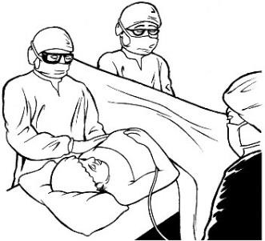
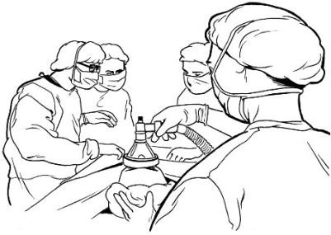
Ko te rehu whānui he rongoā ka
whakamahia kia:
- whakamoe i a koe i te wā
pokanga
- whakawareware i te pokanga
- kia kore e rongo mamae i te
pokanga

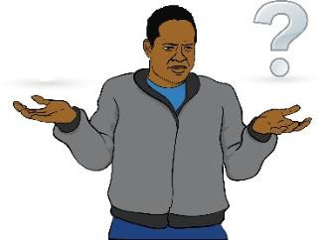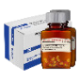
Ko te tukanga whakamātau he maimoatanga e whakamātau tonutia.

Mēnā ka kino pea ngā mate āpiti me tuhi e koe he kupu e kīia nei ka
mārama koe ki ērā momo mate āpiti.

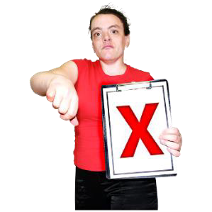
Kei a koe te mōtika ki te:

- kore whakaae ki te ratonga

- huri i oū whakaaro mō te ratonga ahakoa te wā

- whakawhiti kaiwhakarato ina taea

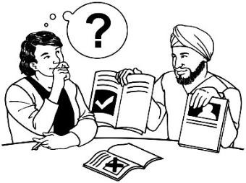
- whiriwhiri mō i te nuinga o ngā maimoatanga.

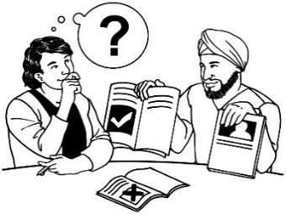
Kāore e taea ētahi maimoatanga te whiriwhiri i mua i te hiahia kia mahia.

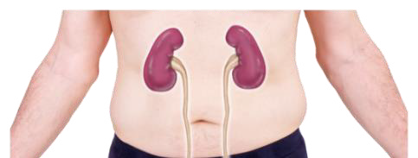
Kei a koe te mana whiriwhiri:

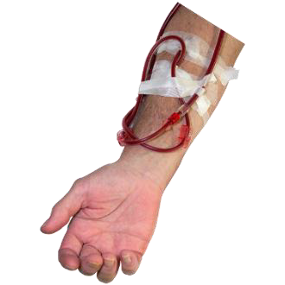
- hei kōrero ina tangohia pea tētahi wāhanga o te tinana hei wāhanga o tētahi maimoatanga

- hei kōrero mō ngā mea ā-tinana pērā i te tō toto

- hei kōrero mō ōu wāhanga tinana:

  - kia whakamahia

  - kia purihia

Mōtika 8: Tautoko
whaka- haumaru

Ka taea e koe tētahi hoa tautoko te mau mai mehemea:

- e haumaru ana

- kāore e pānga atu ki ngā mōtika a tētahi atu.

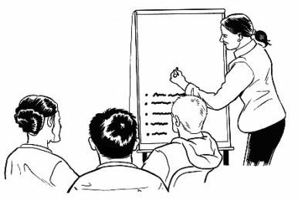
Mōtika 9: Ako me te rangahau

Kei a koe ēnei mōtika mēnā he wāhanga koe o:

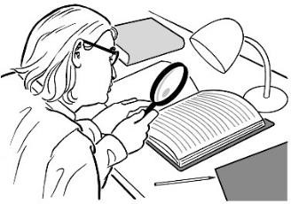
- tētahi whakaako

- tētahi rangahau.

Mōtika 10: Amuamu

Ka taea e koe tētahi amuamu te tuku ki tētahi kaiwhakarato ki tāu e pai ai.

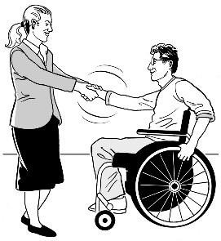
Me whakatikatika tahi e te kaiwhakarato me koe i tō amuamu:

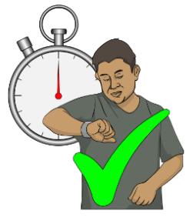
- i runga i te tika

- kia tere.

Me whakamōhio atu i a koe he pēhea e tuku amuamu ai koe.
Amuamu

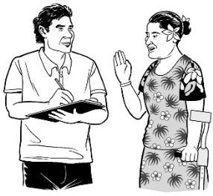
Me kī atu te kaiwhakarato ki a koe:

- kei te aha rātou i a rātou e whai atu ana i tō amuamu

- ka aha nā tō amuamu.

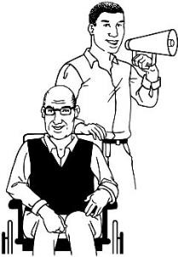
Me whakamōhio atu i a koe mā wai hei tautoko i a koe me tō amuamu:

- kaitautoko hauora

- kaitautoko hauātanga

- te HDC.

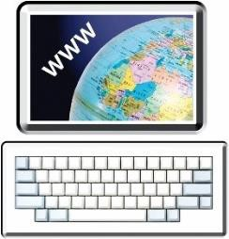
Ka kitea te Tikanga Mōtika i te pae ipurangi o HDC ki:

www.hdc.org.nz/your-rights

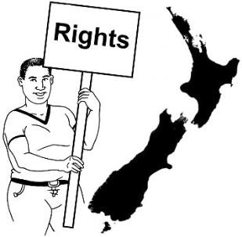
I ētahi wā kāore e taea ētahi kaiwhakarato te whakatutuki i ōu mōtika.
Ōu
Mōtika

Me whakapau kaha ngā kaiwhakaratoki te āwhina i a koe i ngā wā katoa ahakoa kāore e taea e rātou te whakatutuki i ōu mōtika.

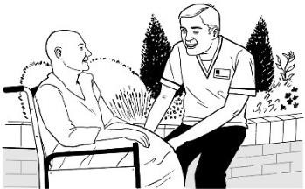
Ka rerekē ētahi mōtika mō ngā ratonga
Mate whakaahuru

mate whakaahuru.

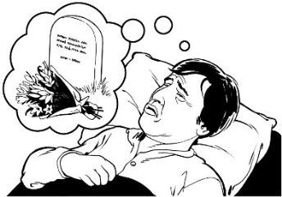
Ko te mate whakaahuru he manaaki pairuri e tautoko ana i ngā tāngata e hiahia tautoko ana kia mate ki tā rātou e whiriwhiri ai.
I raro i te Mōtika 6: Mōhiohio, ka wātea tētahi mātanga hauora ki te kōrero ki a koe mō te mate
whakaahuru ina anake ka pātai atu koe.

Me whakaatu koe i tō matatau ki te whiriwhiri i runga i te mōhio mō te mate whakaahuru.

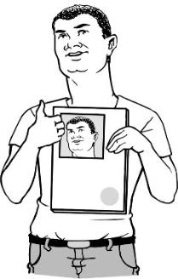
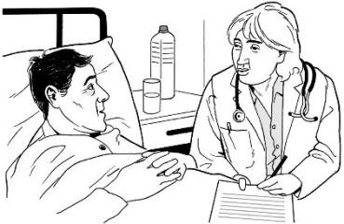
Kāore e taea e koe tētahi tuku tohutohu wawe i mua rā anō mō te mate whakaahuru.
Ko tētahi tohutohu whakamua he mahere ka tuhia e koe ki te kī atu ki tō rata/tākuta he aha koe e hiahia
ai mō āpōpō.
Ka whakamahia he tohutohu wawe inā kore taea e koe ō hiahia te kī
atu ki te kaiwhakarato.

Taku Mahere

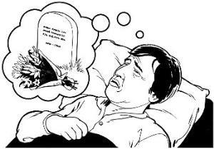
Ehara i te mea me whakamahi e tō tākuta/rata te ratonga mate whakaahuru mōu.

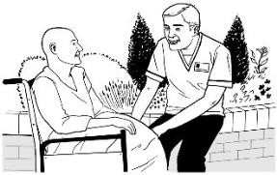
Me manaaki tonu tō tākuta/rata i a koe ahakoa kāore ia e whakamahi ana i te ratonga mate whakaahuru.

Ka kitea he mōhiohio anō mō ōu mōtika me te mate whakaahuru i te pae ipurangi o HDC ki:

https://tinyurl.com/yr35nk6w

I ētahi wā kāore:
Ina whakaaro koe kāore ōu mōtika e tutuki

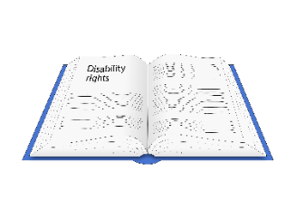
- koe e pai ki tētahi ratonga

- ōu mōtika e tutuki.

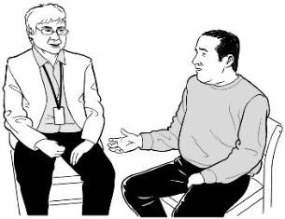
Kia tere te raruraru e whakatikaina me mātua:

- kōrero ki te tangata nāna te ratonga i hoatu

anō hoki

- me kōrero ki te kaiwhakarite ratonga.

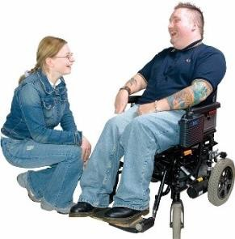
Me pātai atu ki ētahi atu hei tautoko i tō kōrero ki te kaiwhakarato pērā:

- i tō whānau

- i ōu hoa

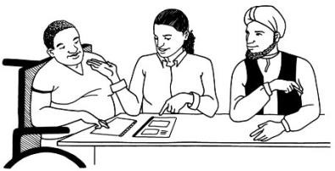
- he kaitautoko nō te Ratonga Hauora Hauātanga ā-Motu.

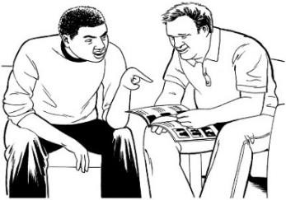
Ka kite ētahi atu mōhiohio mō te Ratonga Hauora Hauātanga ā-Motu ki runga i te whārangi 44.

Me kaua tētahi raruraru e pā atu ki a koe nā te:

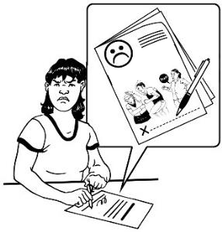
- kōrero ki te kaiwhakarato mō tētahi mea whakararu ana i a koe
Amuamu

- tuku amuamu.

Ki te whakaaro koe kāore ōu mōtika i te whakatutuki mai i tētahi ratonga hauora, hauātanga ka taea te tuku amuamu ki HDC.
Amuamu

Ko tētahi amuamu e tukuna ai ki HDC ka meatia:

- ā-tōkeke nei

- kia pai ai.

Ka tere a HDC ki te whai i tō amuamu i runga i te wā wātea.

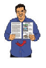
Ka kitea he aratohu Pānui Māmā hei tuku amuamu i roto i te tuhinga nei:

Pānui māmā

He puka tuku amuamu mō tō hauora, te manaaki hauātanga rānei

He puka hei tuku amuamu mō tō hauora me te manaakitanga hauātanga rānei

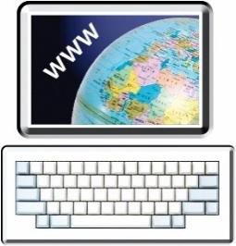
Ka kitea tēnei pukapuka i te pae ipurangi o HDC ki:

https://www.hdc.org.nz/making-a- complaint/make-a-complaint-to- hdc/

Ka whakapā atu ki Te Toihau Hauora, Hauātanga mā te:
Me pēhea e whakapā mai ai

- Waea: 0800 11 22 33
waea

- Īmēra: hdc@hdc.org.nz

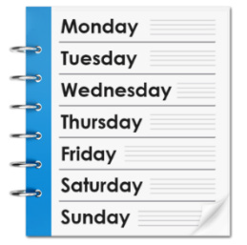
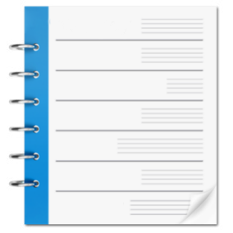
Ka tuwhera hei te:
Mane Tūrei Wenerei Tāite Paraire Rāhoroi Rātapu

- Mane ki te Paraire

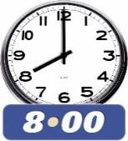
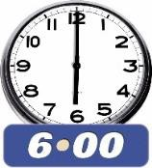
- 8 karaka i te ata ki te 6 karaka i te ahiahipō.

Ka kitea he mōhiohio atu anō mō Te Toihau Hauora, Hauātanga i tō mātou pae ipurangi ki:

www.hdc.org.nz

Mēnā he uaua ki a koe te mahi waea ko te New Zealand Relay he ratonga mō ngā tāngata:

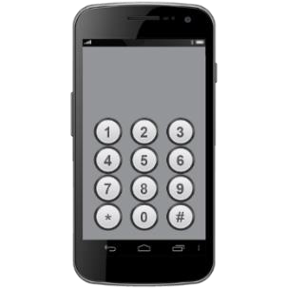
- turi

- turi me te kāpō

- uaua te kōrero

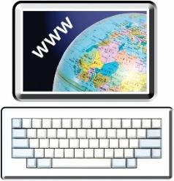
Ka kitea he mōhiohio atu anō mō te ratonga New Zealand Relay ki:

www.nzrelay.co.nz

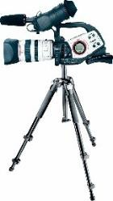
Ka taea hoki a Seeflow te whakamahi hei hopu whitiata kia tukua ki a mātou.

Hei whakamahi Seeflow me rere ki tō rātou pae ipurangi ki:

https://www.seeflow.co.nz/direct

Mēnā ka hiahia tautoko anō hei whakatikatika i tētahi raruraru ki tētahi ratonga hauora hauātanga rānei me whakapā atu ki Ngā Kaitautoko.
Ka taea e Ngā Kaitautoko te tautoko i a koe i te wā e raruraru ana koe me tētahi ratonga hauora,
hauātanga rānei mā te:
- kōrero ki a koe mō te pēhea e
mahi
- kōrero mō ōu mōtika
- whakahoki i āu pātai
- tautoko i a koe hei tuku
amuamu.
Me pēhea e whakapā atu ai ki tētahi ratonga tautoko

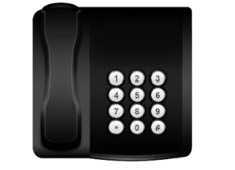
Ka taea te whakapā atu ki Ngā Kaitautoko mā te:

waea

- waea: 0800 555 050

- īmēra:

advocacy@advocacy.org.nz

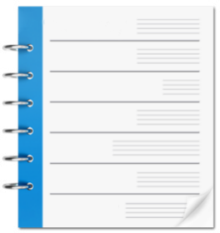
Ka tūwhera hei te:
Mane Tūrei Wenerei Tāite Paraire Rāhoroi Rātapu

- Mane ki te Paraire

- 8 karaka i te ata ki te 6 karaka i te ahiahipō.

Ka kitea he kōrero atu anō mō rātou i tā rātou pae ipurangi ki:

www.advocacy.org.nz

Kua tuhia tēnei mōhiohio e Te Toihau Hauora, Hauātanga.

Kua whakamāoritia ki te Pānui Māmā e te ratonga Make it Easy Māmā Mai nō Ngā Tāngata Tuatahi.

Kua rāhuitia katoatia ngā whakaahua o tēnei tuhinga Pānui Māmā ki tā ngā ture manatā me kaua e whakamahia ina kore e whakaaetia.

2024
47

