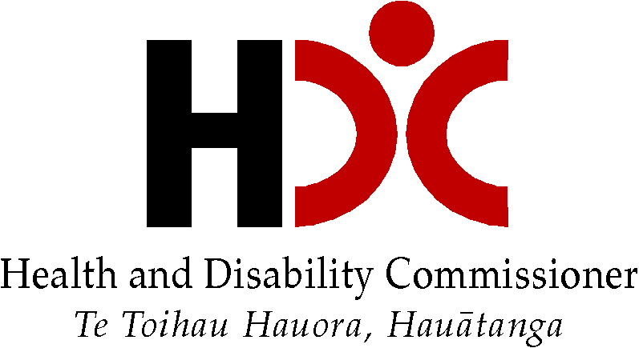

HDC report on complaints to HDC about Residential Disability Support Services

Adapted in 2024 by Accessible Formats Service,
Blind Low Vision NZ, Auckland
TN: The logo on the top of the page is Health and Disability Commissioner | Te Toihau Hauora, Hauātanga.

HDC report on complaints to HDC about Residential Disability Support Services
Some of the information in this report may be upsetting. You may want to have a support person with when you read the report.

Executive summary
Aotearoa New Zealand’s disability support sector is under a lot of pressure. Many groups of people are concerned about:
- There not being enough people working in disability support.
- Disability services not being available sometimes or having closed.
- Some people getting different or less support because of where they live.
- Whether there is enough money for disability support now and in the future.
- Whether enough is being done to keep disabled people safe;
All these problems can mean that some people may not be getting the right support to be part of their communities, to feel good about themselves, and to be able to make decisions about their lives.
HDC thinks that most of the time people working in disability support are doing a good job. But in this report HDC is looking at complaints we have received about residential disability support services in the last five years.
We know it can be hard to make a complaint to HDC about residential disability support services. Some people don’t want to use HDC’s complaints process. Some people feel worried about making a complaint. HDC thinks that there are more unhappy people than just the people we hear from. People may complain to:
- Their residential disability support service
- Funders, such as:
  - Whaikaha | Ministry of Disabled People
  - ACC
  - Health NZ | Te Whatu Ora
- The Human Rights Commission
- The Ombudsman
Again, HDC’s report is about only the residential disability support service complaints we receive.

Context
Disabled people need a safe, warm, reliable, accessible, and affordable place to live. But some disabled people don’t have many good housing options and don’t get to choose where they live, whether it is in a residential disability service or not.
HDC looked at five years of complaints about residential disability support services and found some concerning things:
- Some people’s support plans weren’t being followed.
- Some people weren’t being supported well, including:
  - safety issues in some houses;
  - some people weren’t getting the right medications;
  - some support staff weren’t helping people properly with their health conditions or when they were sick — including when they were becoming sicker; and
  - some support staff weren’t getting enough help or supervision from their managers.
- Some people had staff use restraint or force on them.
- Some people were getting support that didn’t meet their needs.
- Some tāngata whaikaha Māori were not getting disability support that upheld their mana.
- Some residential disability support services were not good at working with or talking to other services, including health services.
- Some disabled people and their families were unhappy with communication from residential disability services, including:
  - not being talked to respectfully or being talked to in a way that did not protect their mana;
  - not having good communication from residential disability service providers when disabled people and/or their families disagreed with them about the support provided;
  - not being given good information about the amount of funding or support they should be receiving; and
  - not being told about changes to support or that support was not going to be provided anymore.
- Some people were not getting support from staff with the right skills.
- Some people had bad experiences when they made a complaint or said they would like things to be different.
HDC thinks that these problems with disability support are playing a part in the problems we identified:
- There are not enough people working in disability support.
- Some people are getting less support because of where they live, rather than the support they need.
- People are confused about what is happening with disability support and Enabling Good Lives (EGL).
- We don’t think enough is being done to make sure disabled people feel safe.
- We don’t always know if people are getting good disability support.
- We are worried about people having good choices about where they live and the support they get.

Recommendations

Recommendations to Whaikaha | Ministry of Disabled People:
In 2023, Whaikaha asked Rachael Schmidt-McCleave to write a report (the Schmidt-McCleave report) about the policies, processes, and practices for managing complaints at a large disability support service. HDC agrees with the recommendations made in the Schmidt-McCleave report. The recommendations HDC thinks are most relevant are:
- HDC, Whaikaha, and service providers all need to make it easier for disabled people and their family or whānau to complain and give feedback about the support they receive.
- Whaikaha need to give disabled people and their family or whānau clear information on what they can expect from disability service providers.
- It would be good if the Nationwide Health and Disability Advocacy Service could give more help to people who live in residential disability services to speak up.
The Schmidt-McCleave report made recommendations to Whaikaha and HDC will be checking in to see how Whaikaha is going with the recommendations.
After looking at the complaints HDC receives about residential disability service providers we have some more recommendations.
HDC recommends that Whaikaha work with disabled people | tāngata whaikaha, their family and whānau, disability service providers, and other funders like ACC and Oranga Tamariki to create a quality framework for all disability support.
A quality framework would help people know what to expect from disability support and what high quality support should look like. It would also help the disability community and sector know how well disability support providers are doing. HDC thinks that clear expectations would make it easier for disabled people and their families to speak up when disability support is not working. There are a few other things that HDC think should be part of a quality framework:
- Service providers could regularly ask people who they support how things are going. How people feel about the service would give providers important information about the quality of the service. Service providers could then tell funders like Whaikaha and ACC what disabled people and whānau are saying about their service.
- There could be general rules for how service providers should respond to complaints from disabled people and whānau. This would help to make sure that all providers are responding to complaints in a fair and consistent way. HDC supports the work Whaikaha is doing right now to create advice about responding to complaints.
- ACC, Health New Zealand | Te Whatu Ora, and Oranga Tamariki could agree to the same quality framework as Whaikaha, so that everyone has the same good quality disability support no matter where their funding comes from.
HDC has some more things it would like Whaikaha to do to improve support provided to people:
- Whaikaha published a report called ‘Disability Support Workforce Community Engagement’ about whether there are enough disability support workers. HDC would like Whaikaha to keep working on making sure there are enough disability support workers now and in the future.
- HDC supports the My Home My Choice programme and the Choice in Community Living option for disability support. However, these programmes are available in only some parts of the country. HDC would like Whaikaha to make Choice in Community Living available all over the country.
- HDC would like Whaikaha to support the creation of tāngata whaikaha Māori-led residential and community-based disability services.
- HDC would like Whaikaha to communicate better with the disability community about progress towards having EGL Systems Transformation all over the country.

Comments about the ‘Independent review of disability support services administered by Whaikaha’:
In May 2024, the government announced an ‘Independent review of disability support services administered by Whaikaha’. The review is about all disability services funded by Whaikaha, not just residential services. But HDC thinks the review is a good opportunity to keep working on giving disabled people good choices about living in the community or having good quality residential services.
HDC is disappointed that there are no tāngata whaikaha Māori or disability community leaders on the three-person review panel. HDC thinks it would be good if the review panel:
- Involved tāngata whaikaha Māori and disability community leaders and whānau in the review, including involving them in developing the recommendations.
- Used the articles and principles of Te Tiriti o Waitangi, the UNCRPD, and EGL to create recommendations that will help create a sustainable, high quality, disability support system for all disabled people.
- Looked at the quality of disability supports, including by looking at recommendations from previous reviews and inquiries.
- Made a long-term disability workforce plan, including training opportunities for residential support staff.
- Considered doing a review of the disability sector similar to the current Aged Care Funding and Services Models Review.

For more information
For copies of this report: https://tinyurl.com/HDCResidentialDisability
For information about making a complaint: https://tinyurl.com/HDCcomplaint

Contact HDC
Email: hdc@hdc.org.nz
Freephone: 0800 11 22 33, open Monday-Friday 8am-6pm
If you are Deaf, hard of hearing, deafblind, speech impaired or find it hard to talk, you can use the New Zealand Relay Service. www.nzrelay.co.nz
End of HDC report on complaints to HDC about Residential Disability Support Services.

