What happens when your complaint

is investigated?

This Easy Read document is from the Health and Disability Commissioner.
What this document is about

The Health and Disability Commissioner is also called HDC.

Your rights when using health or disability services

HDC looks after the rights of people who use:

- health services

- disability services.

To find more information about your rights there is an Easy Read document called:

Your rights when using health or disability services.

You can find this Easy Read document on the HDC website:
https://www.hdc.org.nz/disability/ easy-read-resources/

In this document you can find out about:

What happens when your complaint
is investigated?

- how an investigation works

- how to contact the Health and Disability Commissioner.

HDC may decide to
Investigations
investigate your complaint.

This happens only with a small number of complaints.

If HDC decides to investigate your complaint, that means HDC will look into whether or not you got your rights.

If your complaint is to be investigated, HDC will give your complaint to an Investigator to work on.

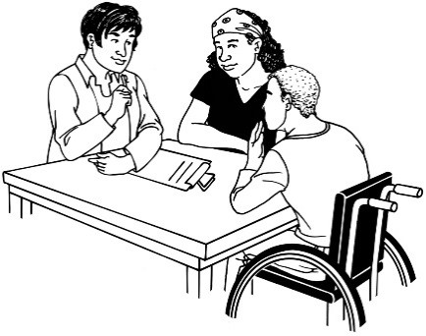
An Investigator is a person who:
- works for HDC
- takes over from your
Complaints Assessor
- talks to you about your
complaint
- collects even more information about your
complaint

If an Investigator is working on your complaint, this means that it is being investigated.

The Investigator will be

impartial.

Impartial means that the Investigator will treat you and the health or disability service
providers the same.
A health or disability service provider can also be
called a service.

The Investigator is not on:

- your side

- the side of the service.

The Investigator will contact the service you have complained about.
The process — what needs to happen

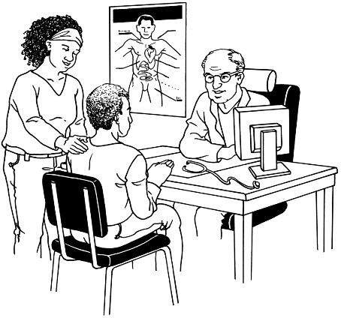
The Investigator will let the service know about:

- your complaint

- the investigation.

The Investigator may ask the service some questions.

The Investigator will ask the service what it thinks about your complaint.

During the investigation, the Investigator may also ask for more information from:

- you or your advocate

- the service you complained about

- other people.

The Investigator may also talk to other people who were there when the thing you are complaining about happened.

These people are known as

witnesses.

The Investigator may also talk to people who know a lot about the service you were using.

These people are known as

Clinical Advisors.

If you want to talk about your investigation, contact your Investigator.
Your Investigator

Please fill out this page so you can contact us.

The name of your Investigator is:

You can call your Investigator on this number:

You can send your Investigator an email at this address:

HDC may try other ways to fix your complaint.
Fixing your complaint

HDC may send your complaint to:

- the Nationwide Health & Disability Advocacy Service

or

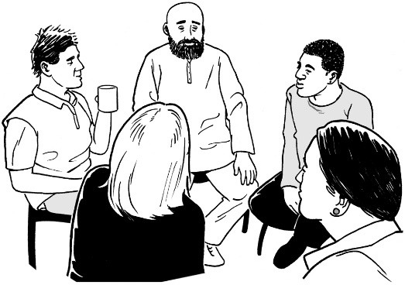
formal mediation.

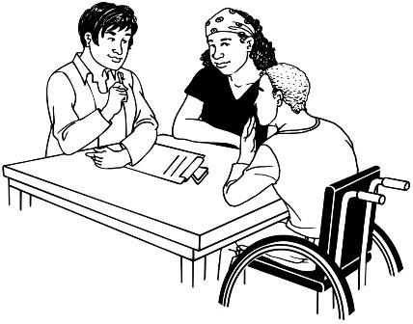
Formal mediation
means bringing you and your service together to:
- talk about the complaint
- work out how to fix the
problem.

If you want to try this way of fixing your complaint, ask your Investigator to make it happen.

When your investigation is finished, HDC will send a draft report to:
What happens next?

- you

- the service you made a complaint about.
A draft report:
- means a report that is not
finished
- tells you about the information that has been collected during the
investigation.

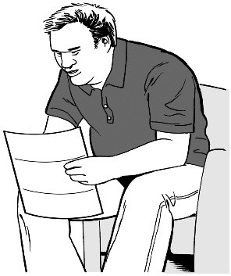
You will have a chance to:

- read the draft report

- say what you think about the draft report

- give the Investigator more information.

HDC will listen to what you say.

HDC will also listen to what your service says.

HDC may then make changes to the draft report.

HDC will then make a final report on your complaint.

A final report means a report that is finished.

This report will be sent to:

- you

- the service you made the complaint about.

The final report will tell you about:

- your complaint

- the investigation

- all the information that was collected during the investigation

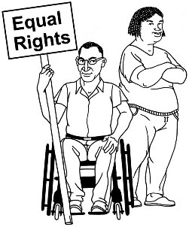
- whether you got your rights

- any action your service should take.

An action is something that needs to be done.

HDC may want your service to take some actions.

These actions could be things like:

- saying sorry to you

- changing how it does things.

The report may also be sent to:

- the Ministry of Health

- registration authorities

- a District Inspector

- somebody else.

HDC will let you know where the report will be sent.

Sometimes, an investigation may be sent to someone called the Director of Proceedings.
Director of Proceedings

This does not happen very often.

It happens if you:

- did not get your rights

- were treated in a very bad way.

If this happens, you will be given information about what:

- this means

- you need to do

- could happen.

How long will the investigation take?
Questions

Some investigations take around 2 years to finish.

Some investigations take around 3 years to finish.

This is because it may take a while to get information.

Your Investigator will contact you every 10 weeks.

Your Investigator will update you on how the investigation is going.

A refund is when you pay for something and then get your money back.

Will an investigation mean I get some money?

HDC cannot tell a service to give you:

compensation

- a refund.
Compensation is when you get money
for something that has gone wrong.

What if I am not happy with the HDC decision?

You cannot change the final decision made by HDC.

You can contact The Office of the Ombudsman.

An Ombudsman can look at the way the investigation was done.

An Ombudsman will check that it was done in a fair and legal way.

You can get in touch with

The Office of the Ombudsman by:

- Phone: 0800 802 602

You do not need to pay any money to phone this number.

Email:

info@ombudsman.parliament.nz

Posting a letter:

The Office of the Ombudsman PO Box 10152
Wellington 6143

Website: www.ombudsman.parliament.nz

If you want to talk about your investigation, contact your Investigator.
How to contact HDC

Contact HDC if you:

- would like to learn more about your rights

- are worried you have not been treated in a good way by a service.

To contact HDC you can phone us on:

0800 11 22 33

You do not need to pay any money to phone this number.

This number is open:

- Monday to Friday

- 8 o’clock in the morning to 6 o’clock in the evening.

You could also write to us at:

The Health and Disability Commissioner
PO Box 1791

Auckland

or look at our website: www.hdc.org.nz

This information has been written by the Health and Disability Commissioner.

It has been translated into Easy Read by the Make it Easy Kia Māmā Mai service of People First New Zealand Ngā Tāngata Tuatahi.

All images used in this Easy Read document are subject to copyright rules and cannot be used without permission.

Published: 2024
27

