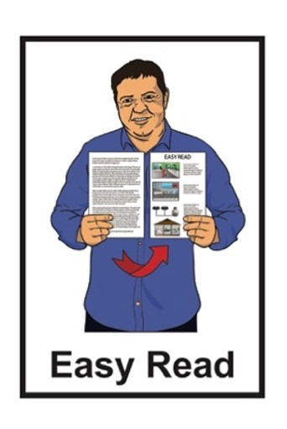
•
HEALTH & DISABILITY COMMISSIONER
TE TOIHAU HAUORA, HAUATANGA

Privacy Statement

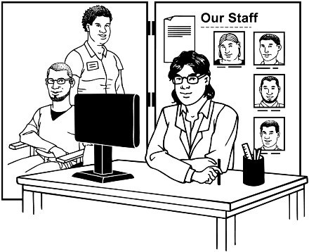

This Easy Read document is:
About this document

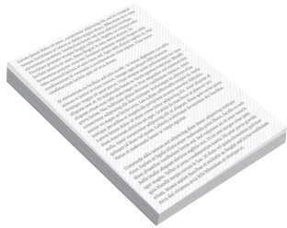
- from the Health and Disability Commissioner

- about their Privacy Statement.
The Health and Disability
Commissioner:
- is also called the HDC
- looks after the rights of
people who use:
o health services
o disability services.

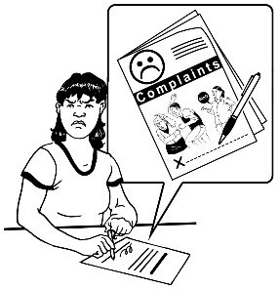
You can read the full privacy statement on the HDC website here:
The HDC Privacy Statement lets people know how information about
them is used when they:
- visit the HDC website:
www.hdc.org.nz
- make a complaint to HDC.

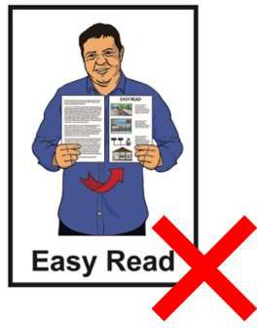
www.hdc.org.nz/privacy-statement

This information is not in Easy Read.

In this Easy Read document the words us and we mean HDC.

How we use your personal information

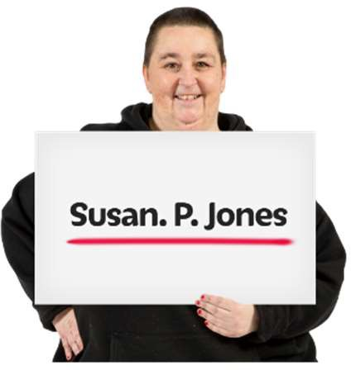
Personal information means information about you like:

- your full name

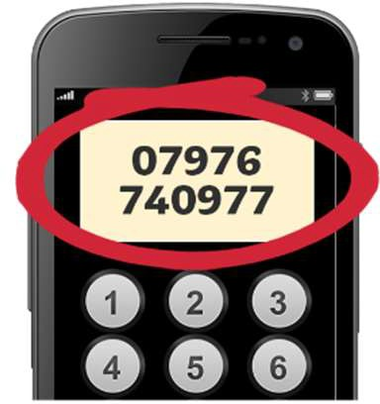
- your contact details like phone number

- your health information

- where you live

- how old you are.

We collect your personal information when you:

- contact us

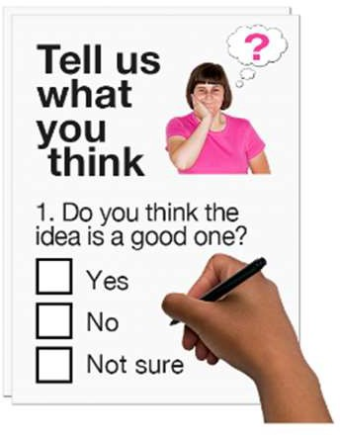
- tell us how we are doing

- order something from us

- make a complaint.

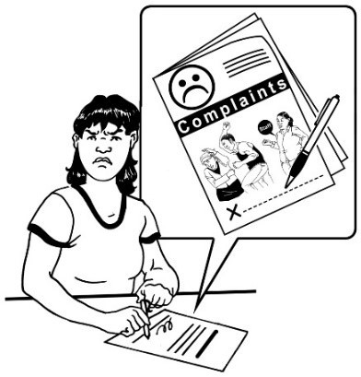
A complaint is telling someone:
- there is a problem
- something is wrong.

We only use your personal information when we need to.

We may share your personal information with:

- the health care / disability services provider you are complaining about so they can answer our questions about your complaint

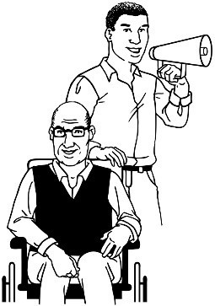
- advocacy services to assist them with managing your complaint

- other health / government organisations

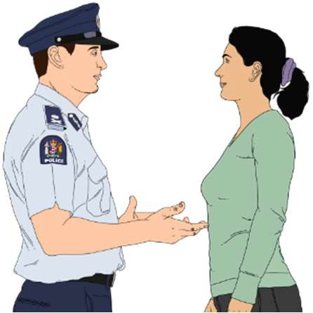
- law enforcement agencies to:

- make sure the law is being followed

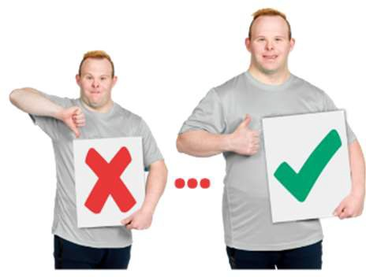
  - stop a bad situation from getting worse

  - make a bad situation better.

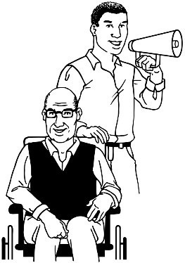
Advocacy services help you speak up for yourself.
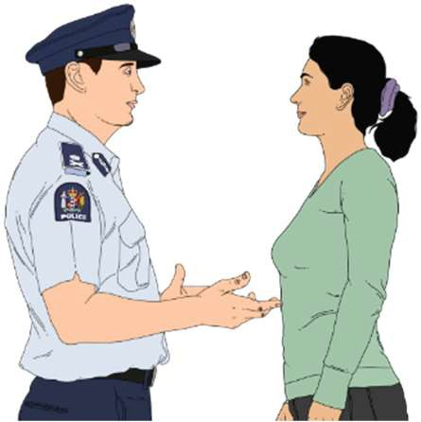
Law enforcement agencies make sure people follow the law.

When we use your personal information we always follow these rules / laws:

- Privacy Act 2020

- Health Information Privacy Code 2020

- our Privacy Statement.

You do not have to give us your personal information to use:
What information we collect

- our website

- information on our website.

Some information is automatically recorded when you use our website such as the:

- search words you use

- pages you look at on the website

- links you click on

- date you visited the website

- time you visited the website.

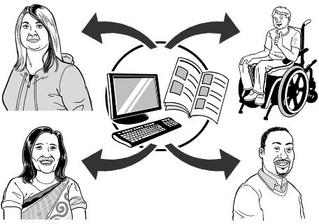
This kind of information will be available to:

- the people who take care of our website

- some HDC staff members

- other government agencies.

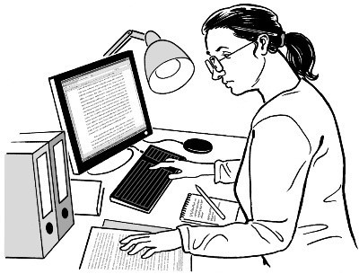
We do not use this kind of information to find out who anyone is.

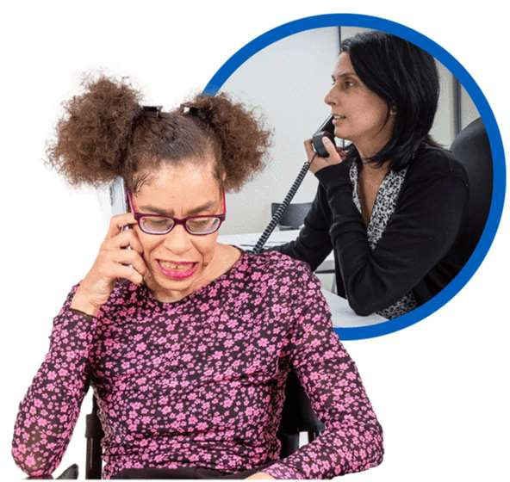
All calls answered by us are recorded.
Call recordings

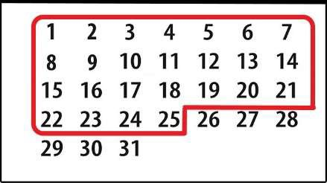
Audio / sound recordings of calls are kept for 25 days.

They are deleted after 25 days unless the recording is needed:

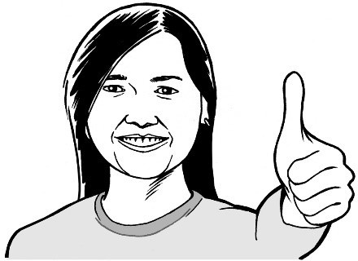
- to make sure calls are done well

- to protect the health and safety of our staff

- for other reasons to do with the law.

Most web browsers are set up to use cookies.
Web browsers are programs you
use to access websites like Google.
Examples of web browsers are:
- Google Chrome
- Firefox
- Safari
- Microsoft Edge.
Cookies

Cookies are small files that websites put on your computer to remember information when you use them.

Cookies on our website:

- do not keep any of your personal information

- are deleted when you close your browser.

You do not have to use cookies to use our website.

You can contact us:
How to contact us

- to view any of your personal information that we have

- if you want us to change any of your personal information that we have.

You can contact us by:

- email

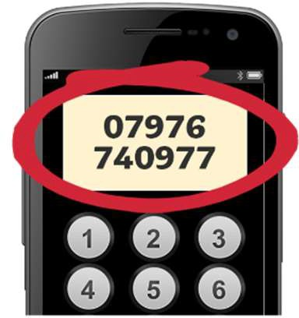
hdc@hdc.org.nz

- phone

0800 11 22 33

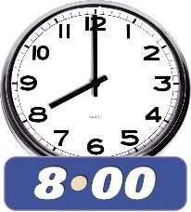
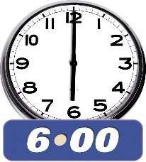
You can call us between:

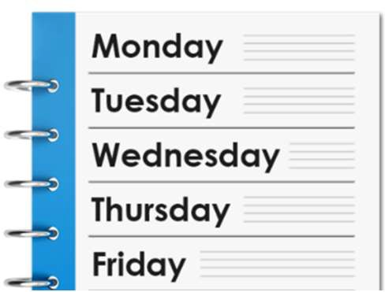
- 8 am to 6 pm

- Monday to Friday.

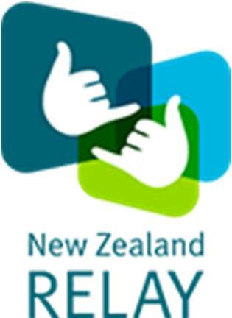
If you find it hard to use the phone the New Zealand Relay service is for people who are:

- Deaf / hard of hearing

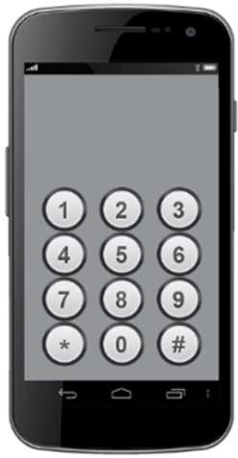
- deafblind

- speech impaired / find it hard to talk.

You can find out more about the New Zealand Relay service at:

www.nzrelay.co.nz

You can also send us mail at this address:

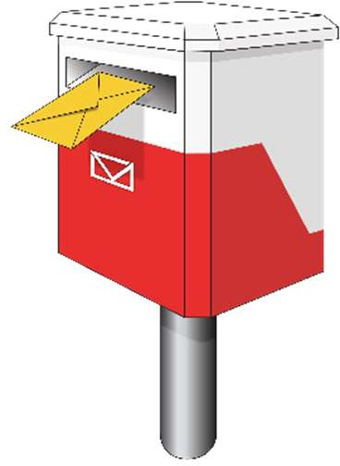
The Privacy Officer

Office of the Health and Disability Commissioner

PO Box 245

Wellington 6140

This information has been written by the Health and Disability Commissioner.

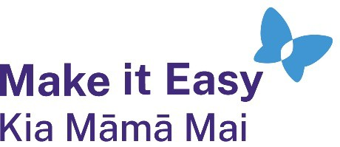
It has been translated into Easy Read by the Make it Easy Kia Māmā Mai service of People First New Zealand Ngā Tāngata Tuatahi.

All images used in this Easy Read document are subject to copyright rules and cannot be used without permission.

2024

